EXPERIMENT 6: ***Neural Correlates of Subjective vs. Objective Measures of Perception, Di Gregorio et al., submitted***

**Introduction**

* **Question**: If alpha power codes solely for subjective experience of confidence during a perception discrimination task, what is the neurophysiological correlate accounting for perceptual accuracy? Do spontaneous fluctuations in posterior predict the level of Subjective Confidence independently of Objective Accuracy?
* **Background** (not only alpha power, but also alpha frequency!) : in general, we know that high-frequency waves, i.e. *beta* and *gamma*, are linked to higher performing states of the brain, while low-frequency ones, i.e. *theta* and *delta*, are linked to lower performing state of the brain such as idling/relaxation states or even deep dream states
  + this is enough to let us think that low-frequency waves are ***slower*** than high-frequency ones, and that they can carry less information
  + coming back to the *alpha band*, one could think that *slower alpha rhythms* (*~ 8Hz*) are related to slower real-time info updates and lower temporal resolutions, which result in a smaller amount of information, while *faster alpha rhythms* (*~ 12Hz*) are related to faster real-time info updates and higher temporal resolutions, which result in a greater amount of information
* **Hypothesis:**
* thus, ***slower prestimulus alpha rhythms indicate a lower accuracy while higher prestimulus alpha rhythms indicate a higher accuracy***
* ***Sampling rate hypothesis****:* considering alpha oscillations, we can imagine a system that updates every 100 ms. In one alpha cycle we have a unit of information to create an envelope which groups important information. The sampling rate hypothesis is the fact that if a system is able to update information at a certain rate it might be more or less capable to produce evidences being more or less quick, so having a faster or slower alpha frequency.
* ***Faster alpha rhythm implies coding, in the same amount of time, more information, and so a faster real time info update.***
* **Aim of the study:**
* proving this relationship has been the aim of *Di Gregorio’s experiment*
* Test if frequency is related to objective accuracy.

**Protocol**

* **EEG analysis prior to stimulus presentation** in order to look at a relationship between pre-stimulus EEG activity (power and frequency) and subjective confidence/objective accuracy

**Method**

* the experiment was tested over *twenty-four participants* that were subjected to a visual stimulus, presented either in the left or right part of a screen, consisting in a chessboard with possibly superimposed grey circles calibrated in order to be perceived *50%* of the times
* Immagine che contiene oggetto, disegnando

  Descrizione generata automaticamentethese are some examples of the stimulus presented to each subject depending on their sensitivity, from the *catch stimulus* (*a*) to the *maximum contrast stimulus* (*d*)
* after the presentation of a stimulus, participants were asked to say if they had seen the grey circles and how much they were confident about their answer on a scale from *1* to *4*
* when extracting data from the *EEG*, a distinction was made between *contralateral* (i.e. on the opposite side of the brain) and *ipsilateral* (i.e. on the same side of the brain) alpha power in order to show the differences between hemispheres when presenting the stimulus at the left or right side of the screen
* Two kind of measures:
  + Subjective **Confidence** (perceived / not perceived)
  + Objective **Accuracy**

**1) Neutral Cue**

* in the first step of the experiment, the stimulus was presented with *no previous cue* for the participant about which side it would appear
* first of all, ***prestimulus alpha power was analysed***, from which it turned out that ***lower alpha power in the contralateral area were related to a higher confidence***, while no correlation was found between confidence and alpha power in the *ipsilateral area*
* this is, again, a proof of the ability of prestimulus alpha power of a certain area to predict level of subjective confidence independently of the accuracy obtained in the discrimination task

**Results**

* then***, prestimulus alpha frequency was analysed*** as well, from which it came out not only that ***faster alpha frequency were related to correct responses*** but also that ***frequency did not correlate to subjective confidence*** (what we think we see might not correspond to what is effectively presented, so power and frequency are dissociated)

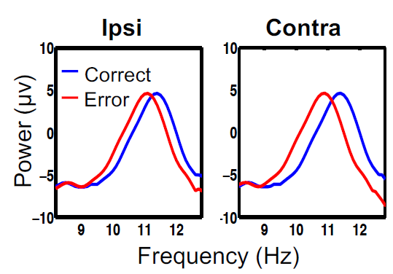 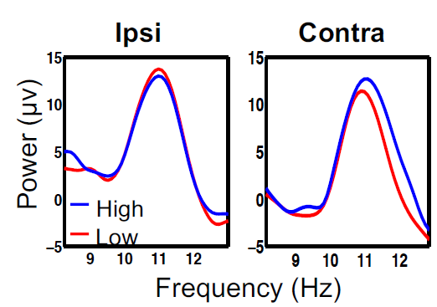

* this proves the ability of *prestimulus alpha frequency* to predict the level of objective accuracy (and not the confidence) in discrimination tasks

**2) Valid Cue**

* so far, the experiment provided data in which subjects have limited predictive capacity of what will be happening next, therefore the next step of the experiment tries to answer whether there is an interplay between confidence and accuracy when the location of the stimulus presentation can be anticipated, namely when a ***predictive cue*** is presented to the subjects before the stimulus
* the cue is shown on the screen before the stimulus in form of an arrow pointing either to the left or to the right depending on the side of the screen in which the chessboard, which is the stimulus, will appear

**Results**

* in this case, an ***analysis of the prestimulus alpha power*** proved not only a *negative correlation between power and confidence in the contralateral area* (the same as before), but also a ***positive correlation between power and confidence in the ipsilateral field*** rather than no correlation at all
* this result shows that, when a valid cue is proposed to the subjects, the alpha power of one hemisphere is actively lowered while the alpha power of the other one is actively enhanced by the brain as a response to the focus of attention on the related hemifield and the subsequent “voluntary” inhibition of the other one
* In ipsilateral you have an active inhibition because you are not expecting anything in that area.
* If you expect on the left, you have a reduction of alpha power in right hemisphere, and in the right hemisphere you have a lot of alpha power to reduce the amount of information that you would perceive in right side.
* as well, an ***analysis of the prestimulus alpha frequency*** proved that the difference of frequencies between *correct* and *wrong responses* was still present in the ipsilateral area and ***even more enhanced in the contralateral one***
* Immagine che contiene mappa

  Descrizione generata automaticamentethis shown when a valid cue is proposed to the subjects, ***their brain actively enhances the frequency of alpha waves, particularly in the area in which the stimulus is expected to appear*** (but also, slightly, in the other one) as a response to this acquired knowledge.
* This enhancement is present in the contralateral hemisphere because we know, from the organization of the visual system, that if we expect something on the right, this will managed by the left part of the visual cortex and viceversa, so in the contralateral part.
* ***The lower the ipsi lateral alpha frequency, the higher the contra lateral alpha frequency, the higher the accuracy***
* ***Correct responses 🡪 alpha in frequency is getting faster in the contralateral***
* ***Wrong responses 🡪 alpha in frequency is getting slower in contralateral***
* In ***ipsilateral and contralateral*** we have the ***opposite behaviour***

**Results: comparison between Neutral Cue and Valid Cue**

* ***Anlaysis of the prestimulus alpha power*** 
  + In ***Neutral Cue*** the object is not provided prior information, so you have ***random fluctuations in alpha power*** and desynchronization facilitates a certain type of response.
  + In ***Valid Cue*** condition you have a prior knowledge about where to expect something. ***Desynchronized contra lateral*** and ***synchronized Ipsi lateral***. This will infer the way in which the sensory processing will work.
  + low cortical excitability (*highly synchronized alpha power*) represents the null hypothesis that no stimulus is going to appear at that location, known as the *conservative criterion*
  + high cortical excitability (*desynchronized alpha power*) favour the alternative hypothesis that the stimulus will appear at that location, known as the *liberal criterion*
* ***Analysis of the prestimulus alpha frequency*** 
  + On the other hand, ***alpha speed accounts for the spatiotemporal resolution of the visual system and predicts its accuracy*** by setting the pace of visual temporal units refresh rate and the updating of sensory input information
* *faster alpha oscillations* will lead to *higher sampling resolution per time unit* allowing *more accurate spatiotemporal information decoding* due to a very efficient neural coding
* *slower alpha oscillations* will lead to *lower sampling resolution per time unit* allowing *less accurate spatiotemporal information decoding* due to a less efficient neural coding
* instead, when contextual information is provided allowing for ***top-down prediction of the to be attended location***, the visual system ***optimizes the top-down control of alpha power*** to allocate faster sampling rate (*faster alpha frequency*) exclusively at the attended location in order to match what we think we see with what is effectively out there
* The result is that when we inform a subject about where possibly the stimulus is gonna be presented, actually the resources are located where the stimulus is gonna be presented, the power of alpha is responsible for directing the hypothesis in one direction rather than the other and the frequency is the amount of energy allocated into one position in space where all the resources are determined.